My IP address:192.168.0.106

Destination Server IP address: 103.230.106.216

**HTTP REQUEST:**

**1.**

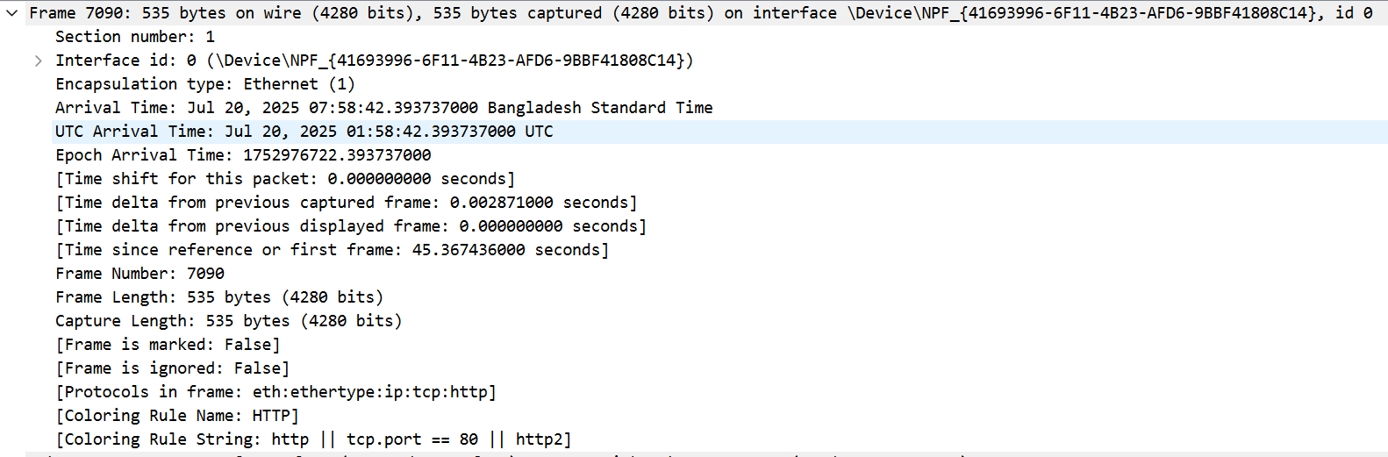

Frame is the PDU of Data Link Layer.

**2.**

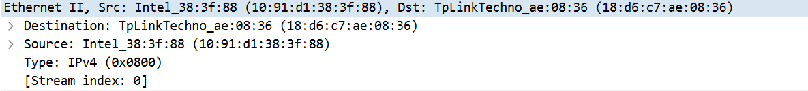

The protocol displayed is Ethernet II, which operates at the Data Link Layer. It includes MAC addresses for both the source (10:91:d1:38:3f:88) and destination (18:d6:c7:ae:08:36).

**3.**

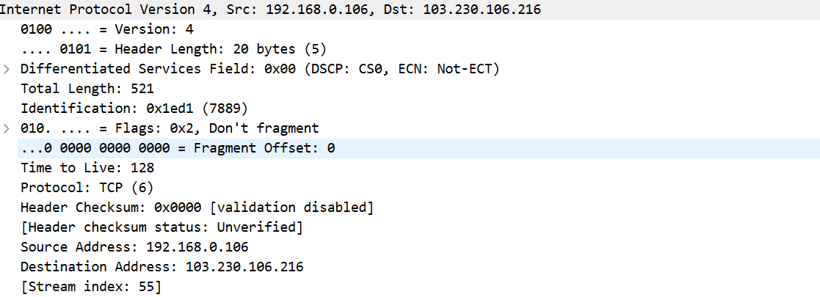

This packet belongs to the Network Layer (Layer 3) of the OSI model. The Network Layer is responsible for the delivery of individual packets from the source host to the destination host across multiple networks.

* Protocol: IPv4
* Source IP address: 192.168.0.106
* Destination IP address: 103.230.106.216
* Total Length: 521 bytes (includes both header and data)

This IPv4 packet ensures logical addressing and routing, enabling it to travel from a private network to a public IP address on the internet.

**4.**

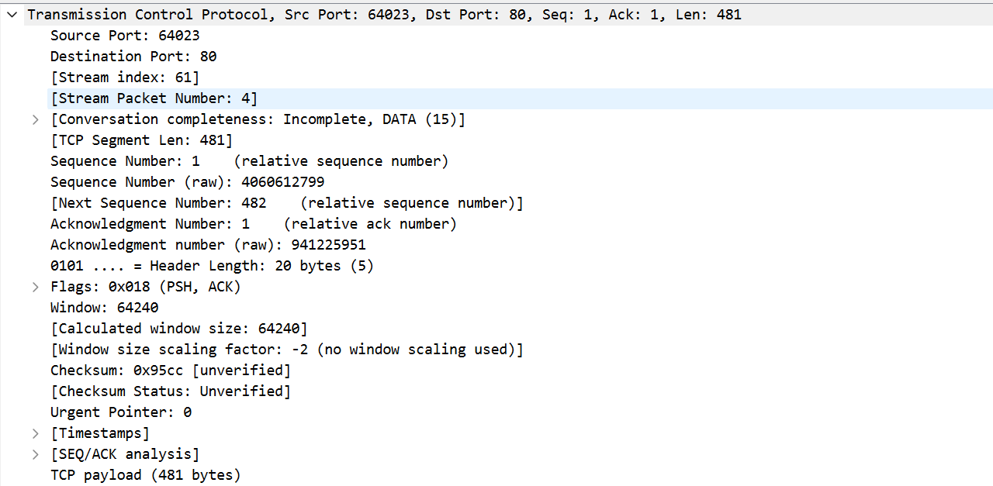

This TCP segment operates at the Transport Layer (Layer 4) of the OSI model, where data is being transmitted from source port 64023 to destination port 80 (HTTP). The packet is part of stream 61 and is the 4th packet in that stream, carrying 481 bytes of application data with a relative sequence number starting at 1. The TCP flags set are PSH and ACK, indicating that the sender is pushing data for immediate processing while acknowledging received data. The sequence number 4006612799 and acknowledgment number 941225951, and the window size is 64240, with no window scaling or urgent data in use.

**5.**

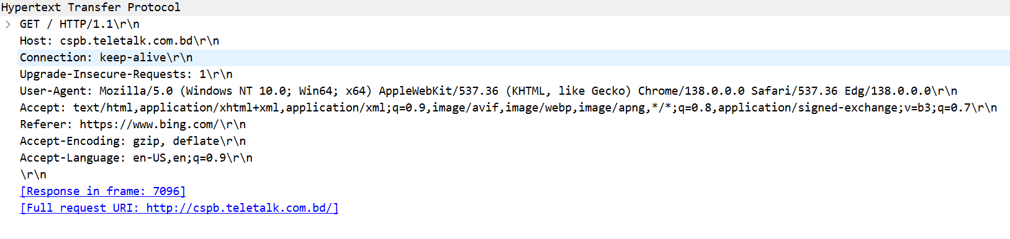

An HTTP GET request from the application layer (Layer 7) of the OSI model, where a client is requesting the root resource from the server at cspb.teletalk.com.bd using HTTP/1.1. The request includes several headers: Connection: keep-alive to maintain the TCP connection, Upgrade-Insecure-Requests: 1 to prefer secure (HTTPS) connections. It also includes Accept, Accept-Encoding, and Accept-Language headers indicating the types of content, compression methods, and languages the client can handle. The Referer header shows the request originated from https://www.bing.com/. A link to the full request URI (http://cspb.teletalk.com.bd/) and a reference to the corresponding response frame (7096) are also included.

**HTTP RESPONSE:**

**1.**

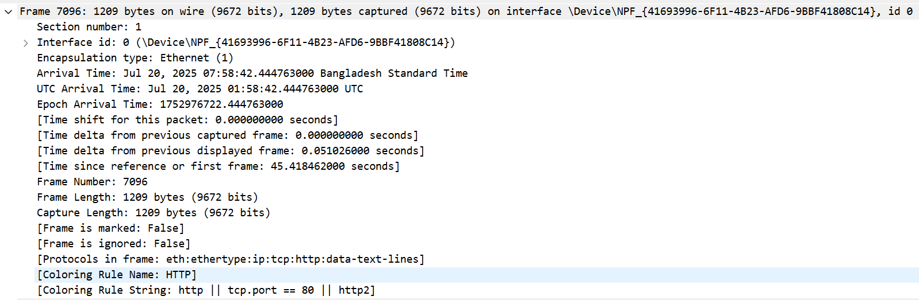

This is the Data link layer of the HTTP response.

**2.**

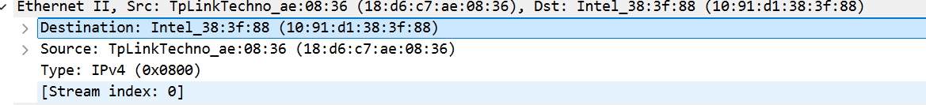

The protocol displayed is Ethernet II, which operates at the Data Link Layer. It includes MAC addresses for both the source (18:d6:c7:ae:08:36) and destination (10:91:d1:38:3f:88).

**3.**

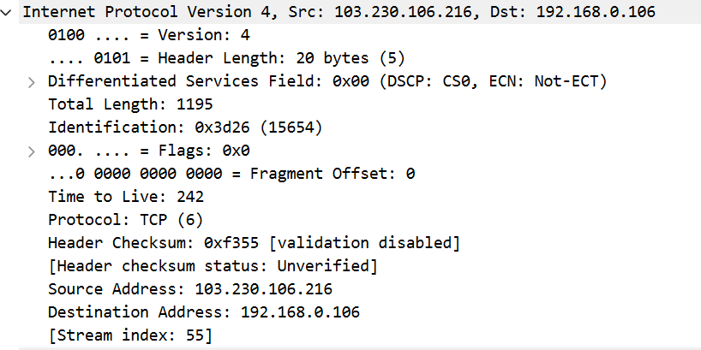

This packet belongs to the Network Layer (Layer 3) of the OSI model. The Network Layer is responsible for the delivery of individual packets from the source host to the destination host across multiple networks.

* Protocol: IPv4
* Source IP address: 103.230.106.216
* Destination IP address: 192.168.0.106
* Total Length: 1195 bytes (includes both header and data)

**4.**

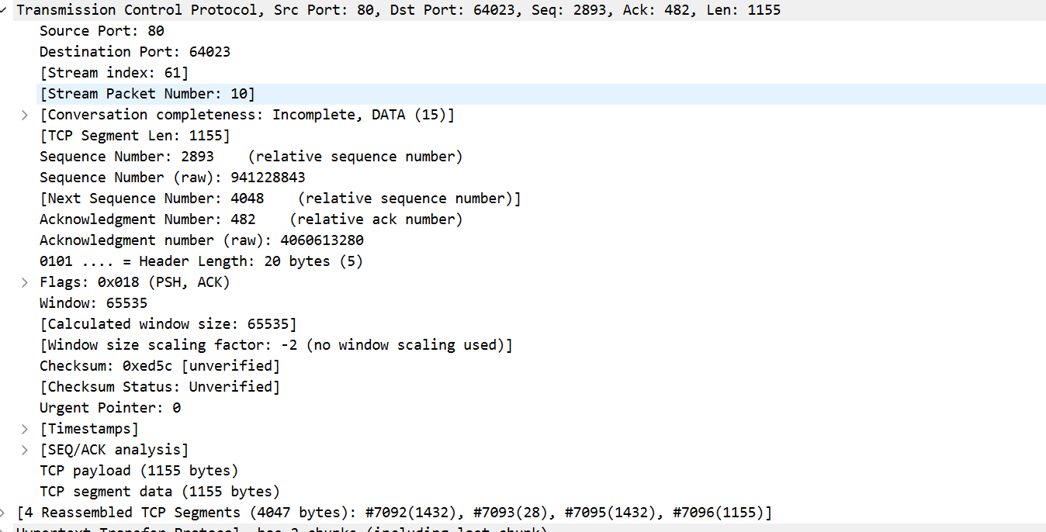

This TCP segment operates at the Transport Layer (Layer 4) of the OSI model, where communication is occurring from source port 80 (commonly used for HTTP) to destination port 64023. The TCP sequence number is 2893, and the acknowledgment number is 482, indicating the sender has received data up to byte 481 from the other side. The TCP segment length is 1155 bytes, and the TCP payload matches this size, indicating that it carries application-level data. The stream index is 61 and the stream packet number is 10, meaning it's part of a specific TCP data stream and represents the 10th packet in that stream. The segment has the PSH and ACK flags set, meaning it is pushing data to the receiving application and acknowledging received data. The window size is 65535, indicating the receiver's buffer space. No window scaling is used here. IAt the bottom, it indicates this packet is part of a reassembled TCP stream that includes segments #7092, #7093, #7095, and #7096, hinting at HTTP data being reconstructed across multiple TCP packets.

**5.**

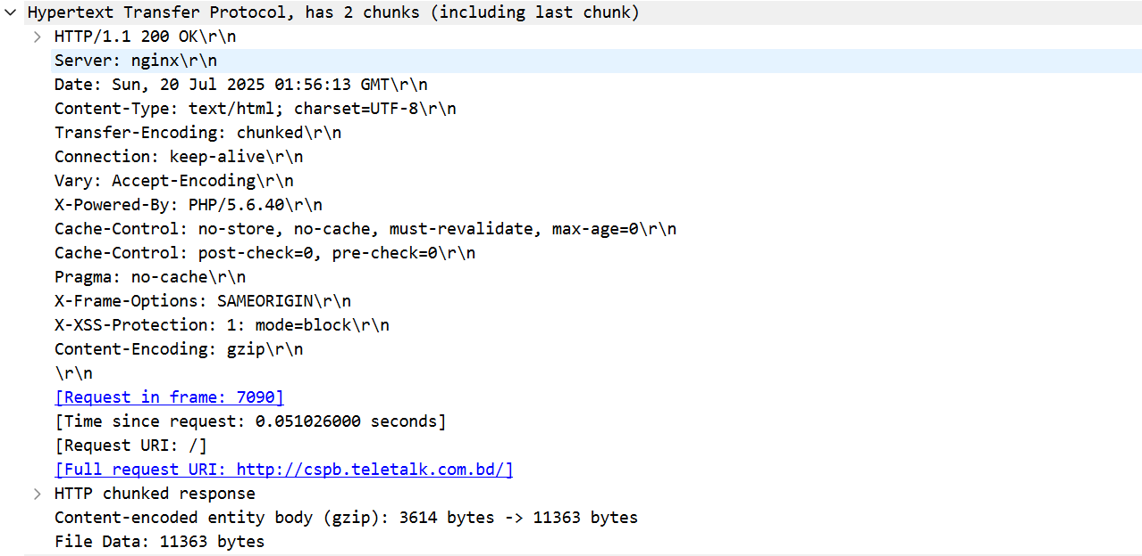

The server responds with HTTP/1.1 200 OK, indicating that the request was processed successfully. The response uses keep-alive for the connection and supports compressed (encoded) responses. The request that triggered this response is noted to be in frame 7090, and the request URI is /, with the full URL being http://cspb.teletalk.com.bd/. The body of the response, originally 3614 bytes compressed, expands to 11363 bytes after decompression, which is noted as the file data. This is a typical HTTP chunked response delivering a full HTML web page.